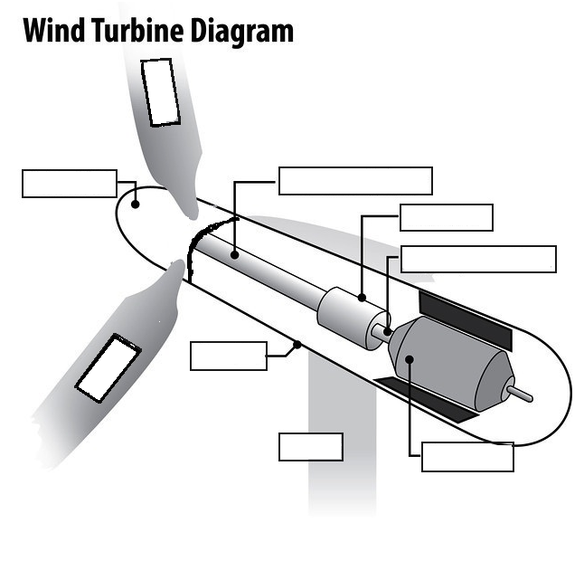
Name:

Instructions: Color and label the following

Rotor Hub – RED
Blade/Prop – PURPLE
Nacelle – LIGHT BLUE
Low-speed Shaft – DARK GREEN
Gearbox – LIGHT GREEN
High-speed shaft – YELLOW
Generator – ORANGE
Tower – DARK BLUE

